**Reproductive Cycle and Incubation Year:**

Female snow crabs have either a one or two-year cycle of egg incubation before larvae hatch. The goal is first to determine the length of the incubation cycle for a given female and, in the case of a two-year cycle, determine whether the egg clutch is in its first or second year of incubation.

Partial identification of a two-year incubation cycle may be determined from the presence of two distinct groups of egg or gonad development stages among an otherwise homogenous group of females. If the groups are sufficiently different, statistical analyses can be applied to separate them and infer the length of the incubation cycle. In contrast, we expect that females in a one-year reproductive cycle would have homogeneous rather than heterogeneous gonad and egg development stages. **However, differentiating between a one-year cycle female and a two-year cycle female in its first year of incubation would be difficult in a mixed sample.**

**Incubation Year from Gonad Condition (2002 data):**

*The relationship between female gonad weight and crab size data from 2002 was regressed against time to model seasonal variations. Bimodal patterns in the gonad weights at any given time were then used to determine the year of the reproductive cycle.*

A two-component linear regression mixture was fit to the log-transformed gonad weight and carapace size. This model has a total of seven parameters: two intercepts, two slopes, the proportion associated with the first linear regression component and two error parameters. Parameters were obtained using maximum likelihood estimation using ‘optim’ in the R ‘stats’ package (Ref). This approach not only allows the estimation of the parameters from each reproductive cycle, but also allows for their probabilitistic identification for a given crab size and gonad weight (Figure 1).

Assuming that the weightier gonad group represents females in their second year of incubation, we include an extra 12 months in the estimate of the elaspsed time since eggs were laid. The resulting progression of gonad weight is fairly constant through time (Figure 2). The hepatopancreas might show a reverse trend as it generally serves as an energy source for gonad development. In contrast, individual dry egg weights generally decreased through time (Figure 3). This might be explained by a decrease in yolk content as the eggs develop, leading to a decrease in dry weights as the vitellin fats are consumed during embryonic development.

|  |  |
| --- | --- |
| cid:image001.png@01D4DF23.410568F0 | cid:image002.png@01D4DF23.410568F0 |
| cid:image003.png@01D4DF23.410568F0 | cid:image004.png@01D4DF23.410568F0 |

**Figure 1**: Gonad weight versus carapace width for female snow crab by month. A regression mixture analysis was applied to separate two groups of gonad weights. The larger gonads are identified as females in the second year of an incubation cycle (green) while the smaller gonads (red) are associated with females in the first year of an incubation cycle.

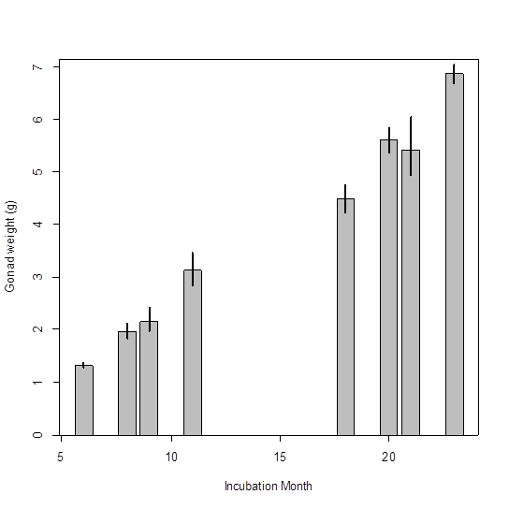

**Figure 2**: Predicted gonad weights for females of size 80mm CW as a function of incubation month.

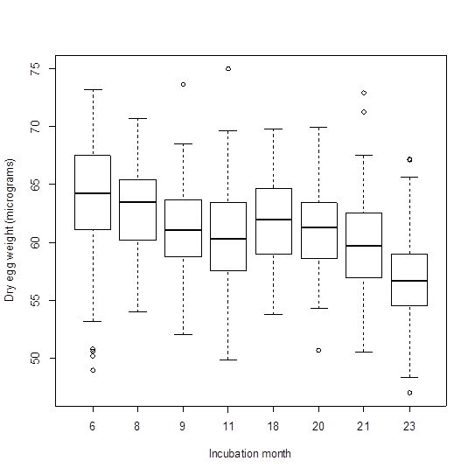

**Figure 3**: Individual egg weights as a function of incubation month.